First download Anvil Studio From: insert url here pls

Make sure you have opened an empty file so that there aren’t any fixed preferences

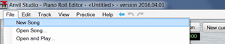

go into preferences

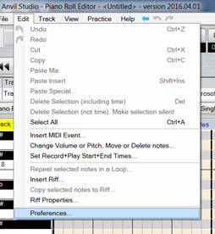

Click on the midi tab

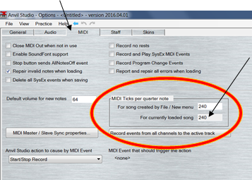

!!! MAKE SURE TICKS = 240!!!

this will make for smooth integer quantization

Next import your midi file by clicking on merge song:

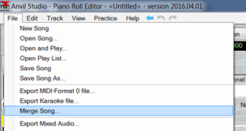

for this I am using the tune that is played when super Mario is invincible

You will have an extra track but you can delete it by right clicking the tick on the left and selecting delete track

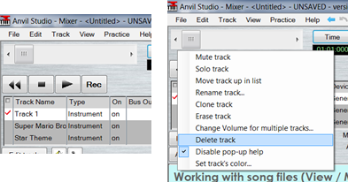

You will be in the mixer view

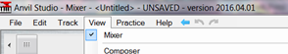

However, you want to be in the “Piano Roll Editor” to check that you have only one note playing at a time in each track

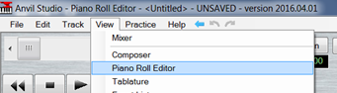

While doing this you will want to check what the smallest division of note is, in this case it is 16th notes as all the notes start on at least the 16th’s line

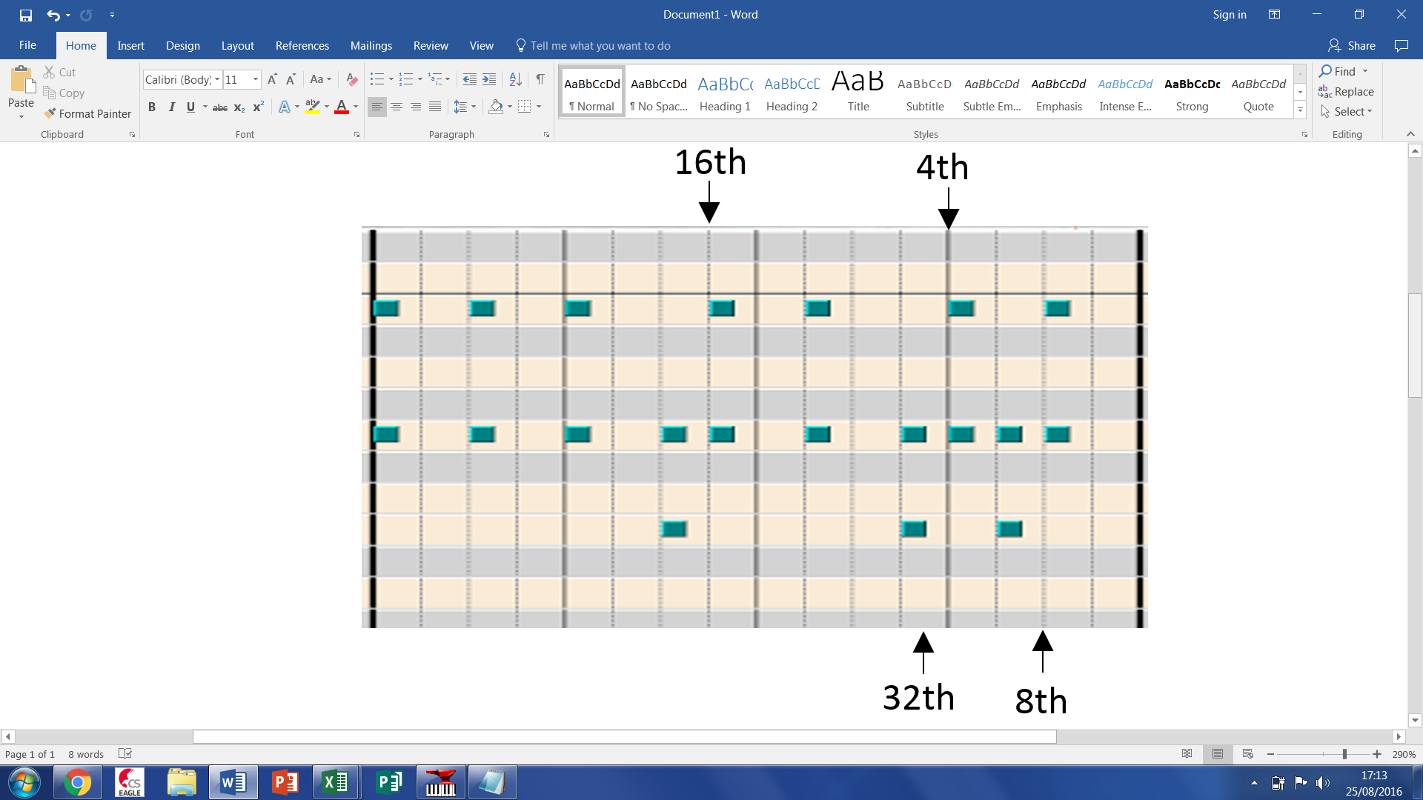

Once you have checked your tracks you will have to quantize (Align the notes) with the value you just found:

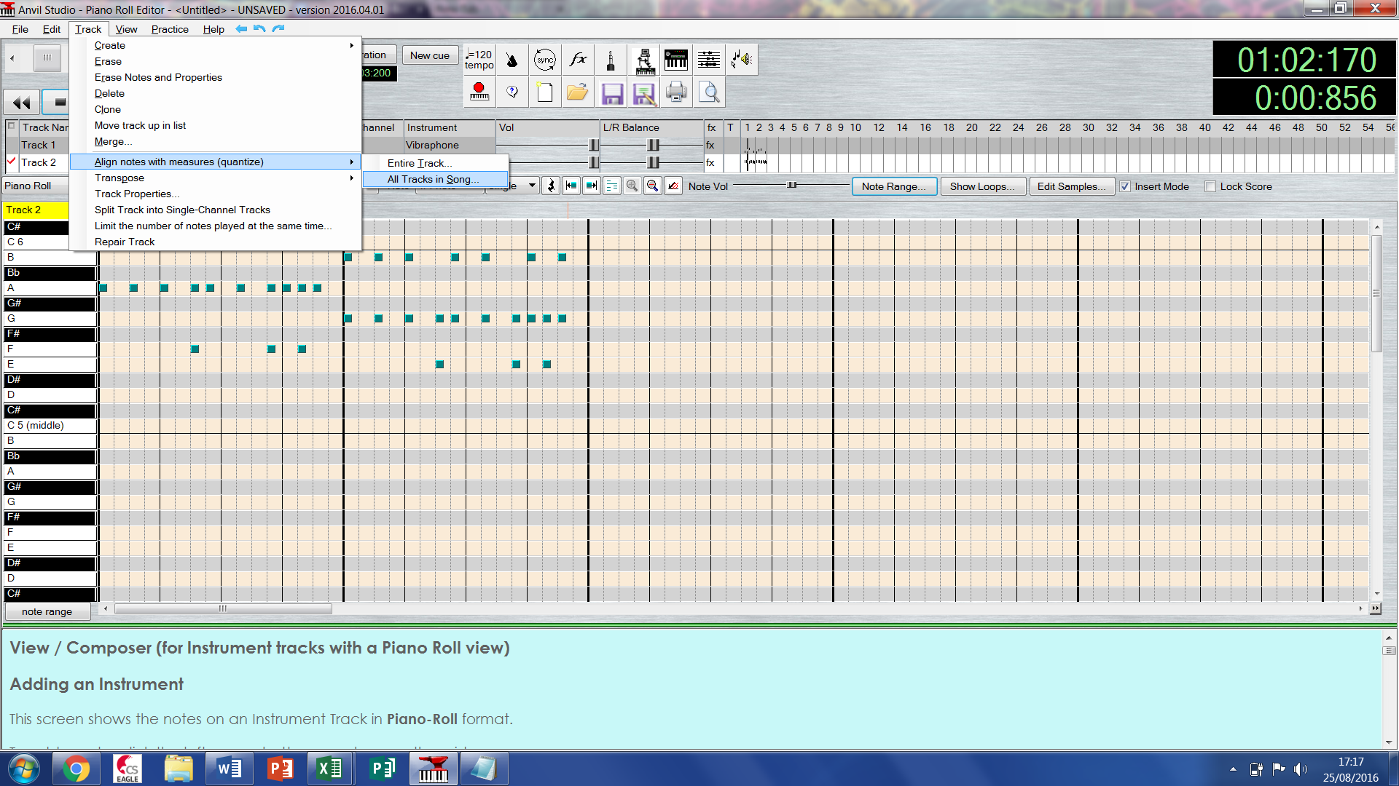

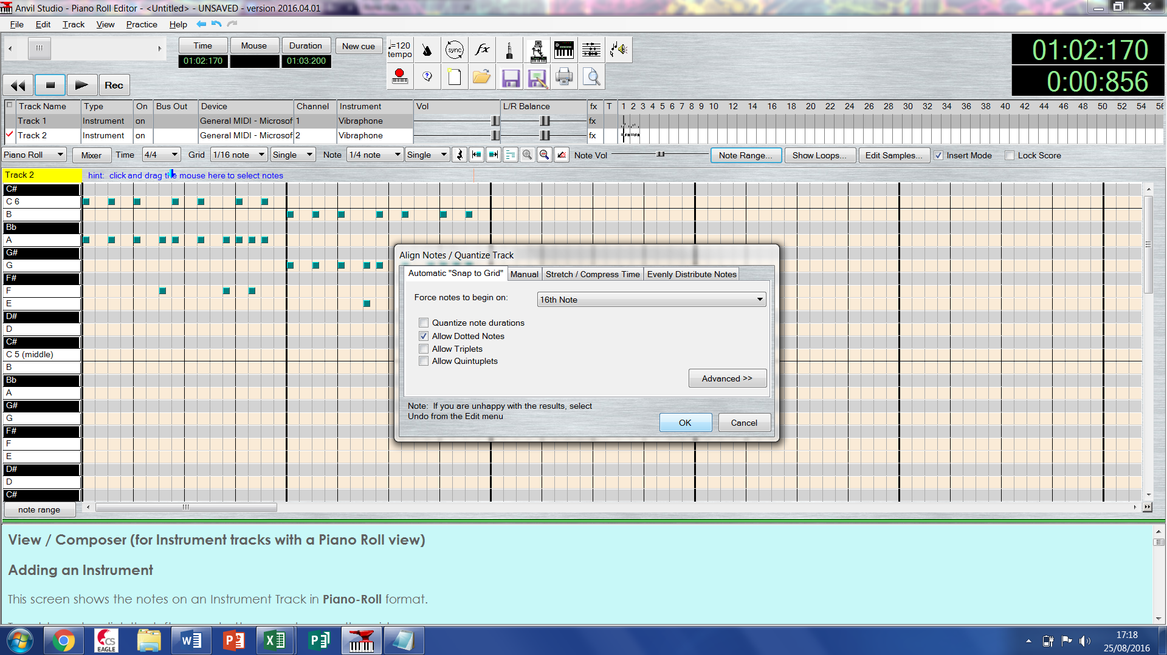

Then go into the event list

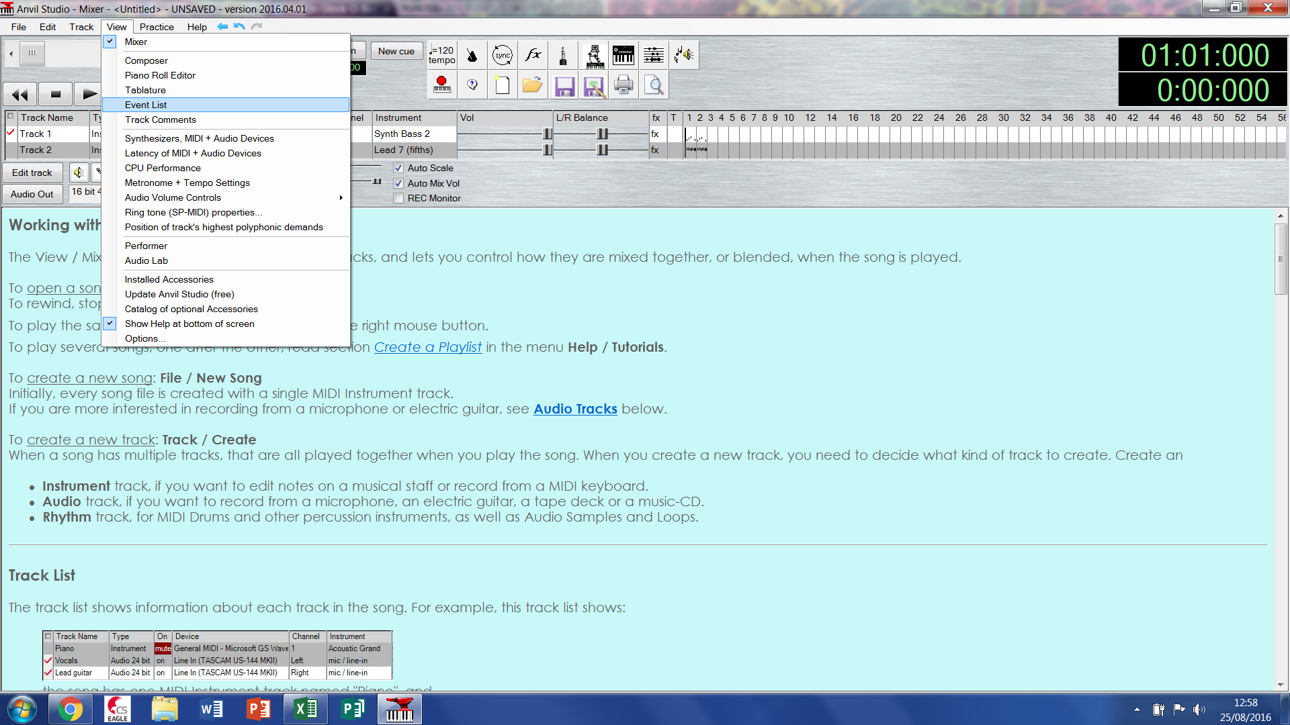

It should look something like this

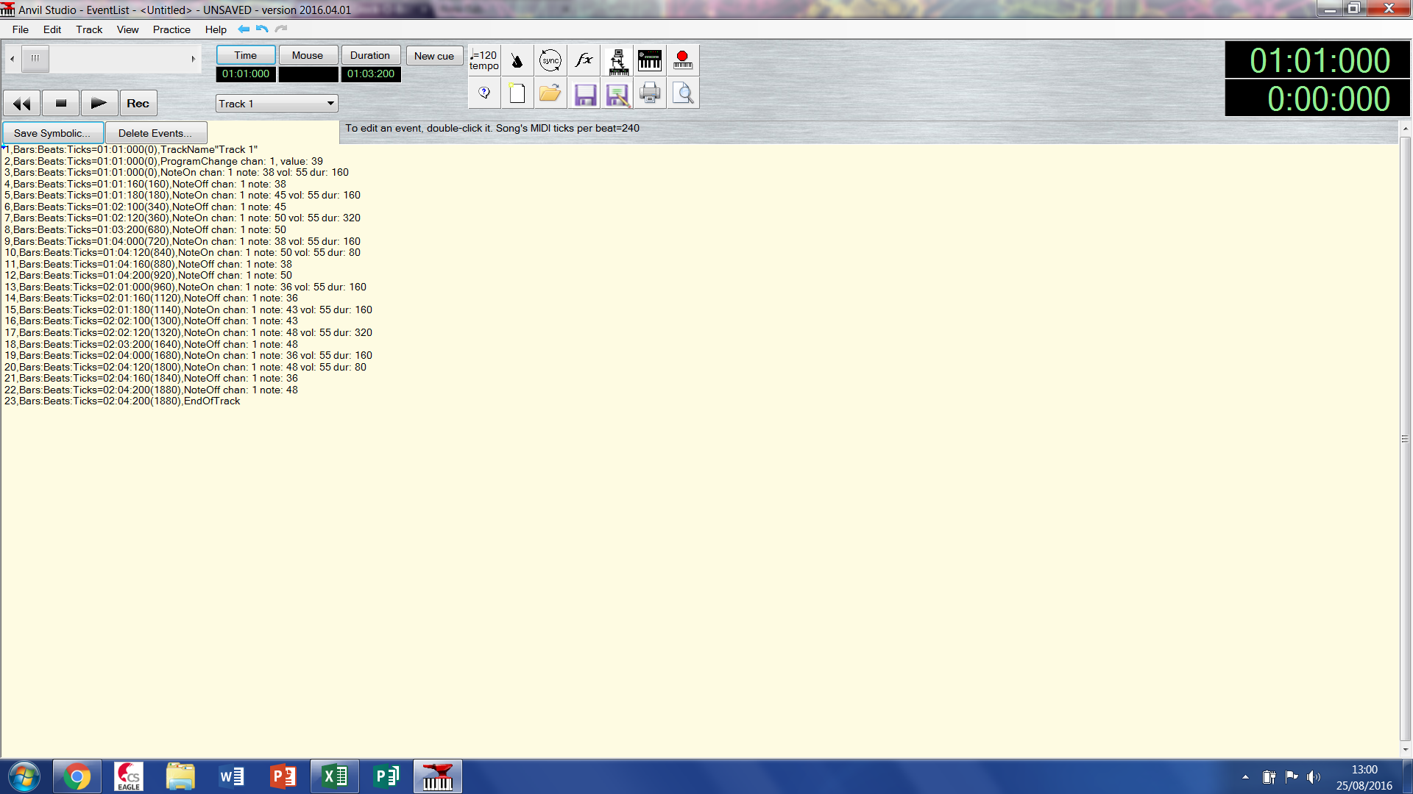

Make sure you have set your time mode to bars beats and ticks

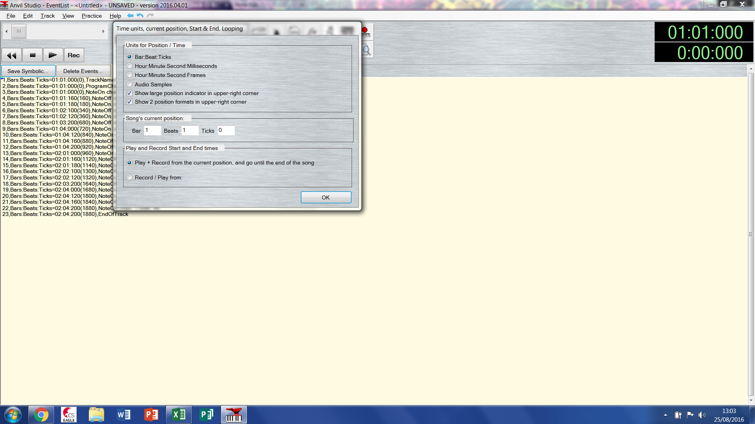

Save symbolic and add in the colons in using notepad’s find and replace so that the data is properly delimited by the colons :

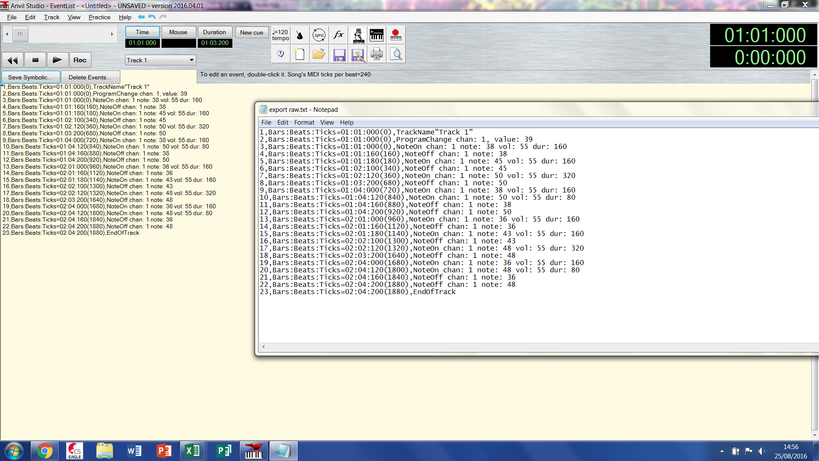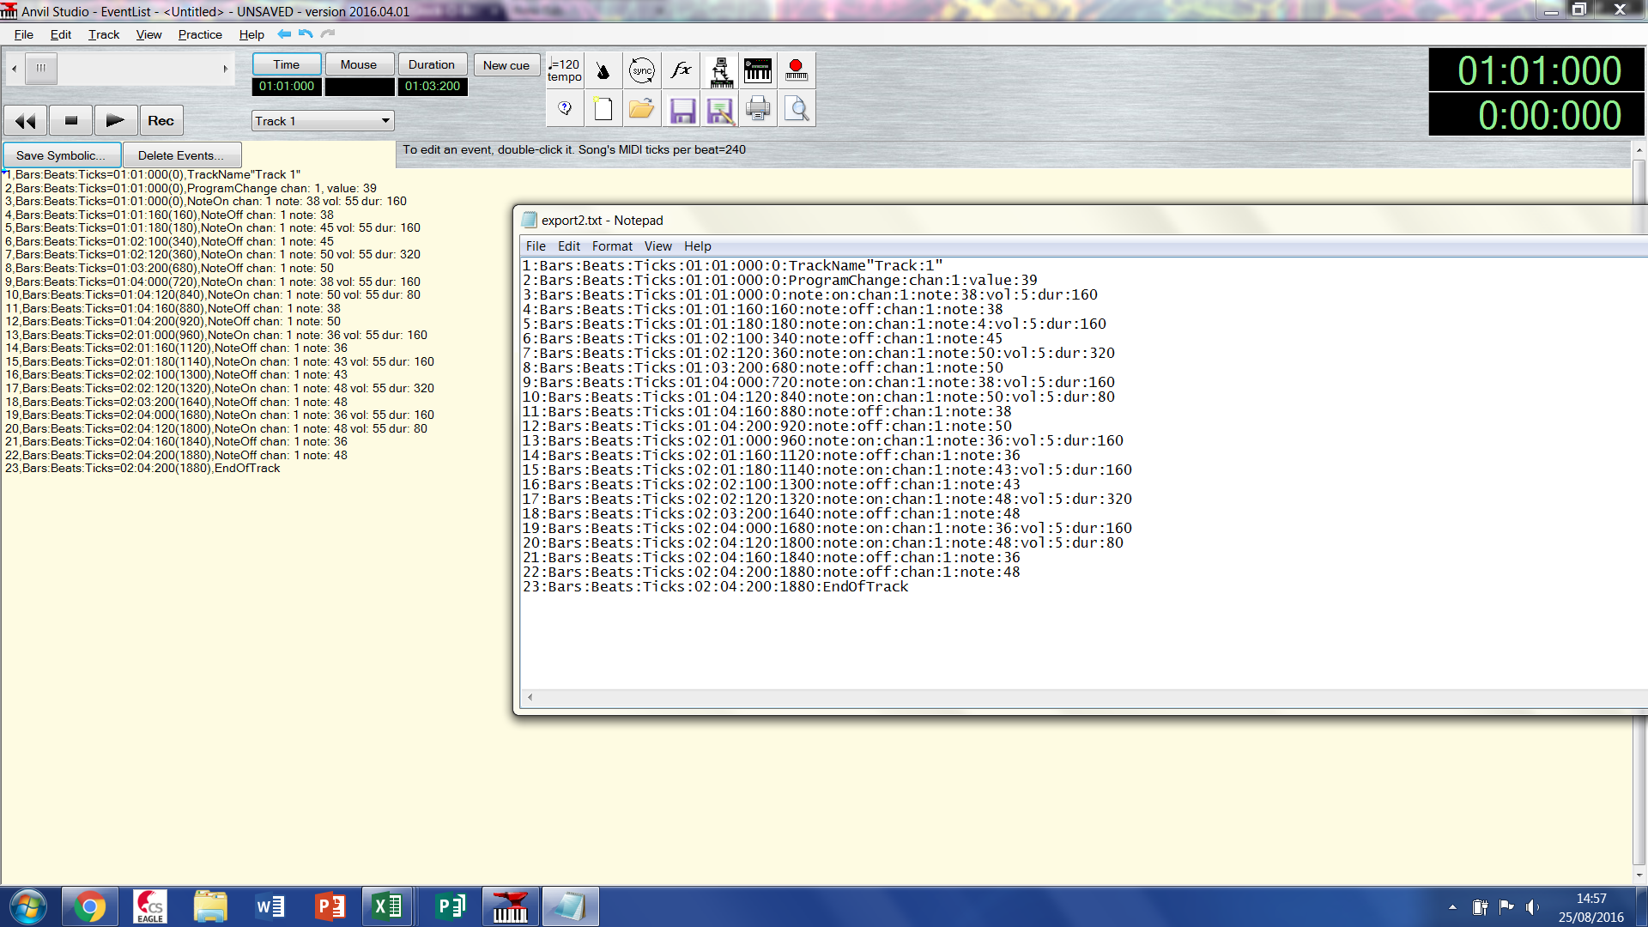

Before: After:

then open it in excel and you will be met with a menu like this:

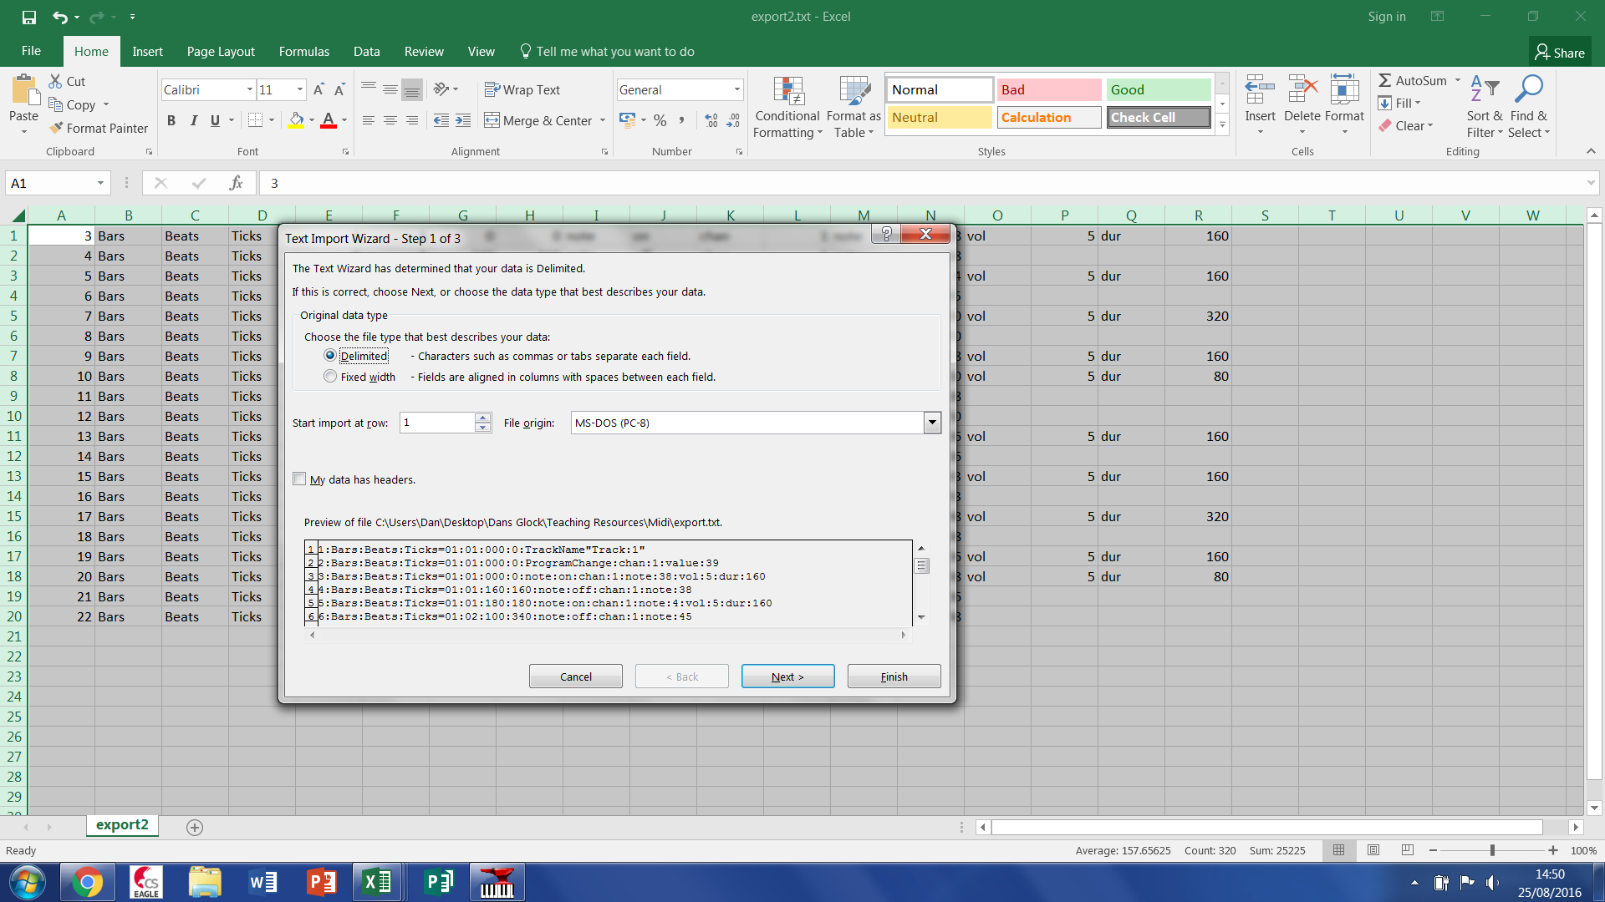

First click next, then the empty box and type “:” without the quote marks, finally click finished, you will then see something like this:

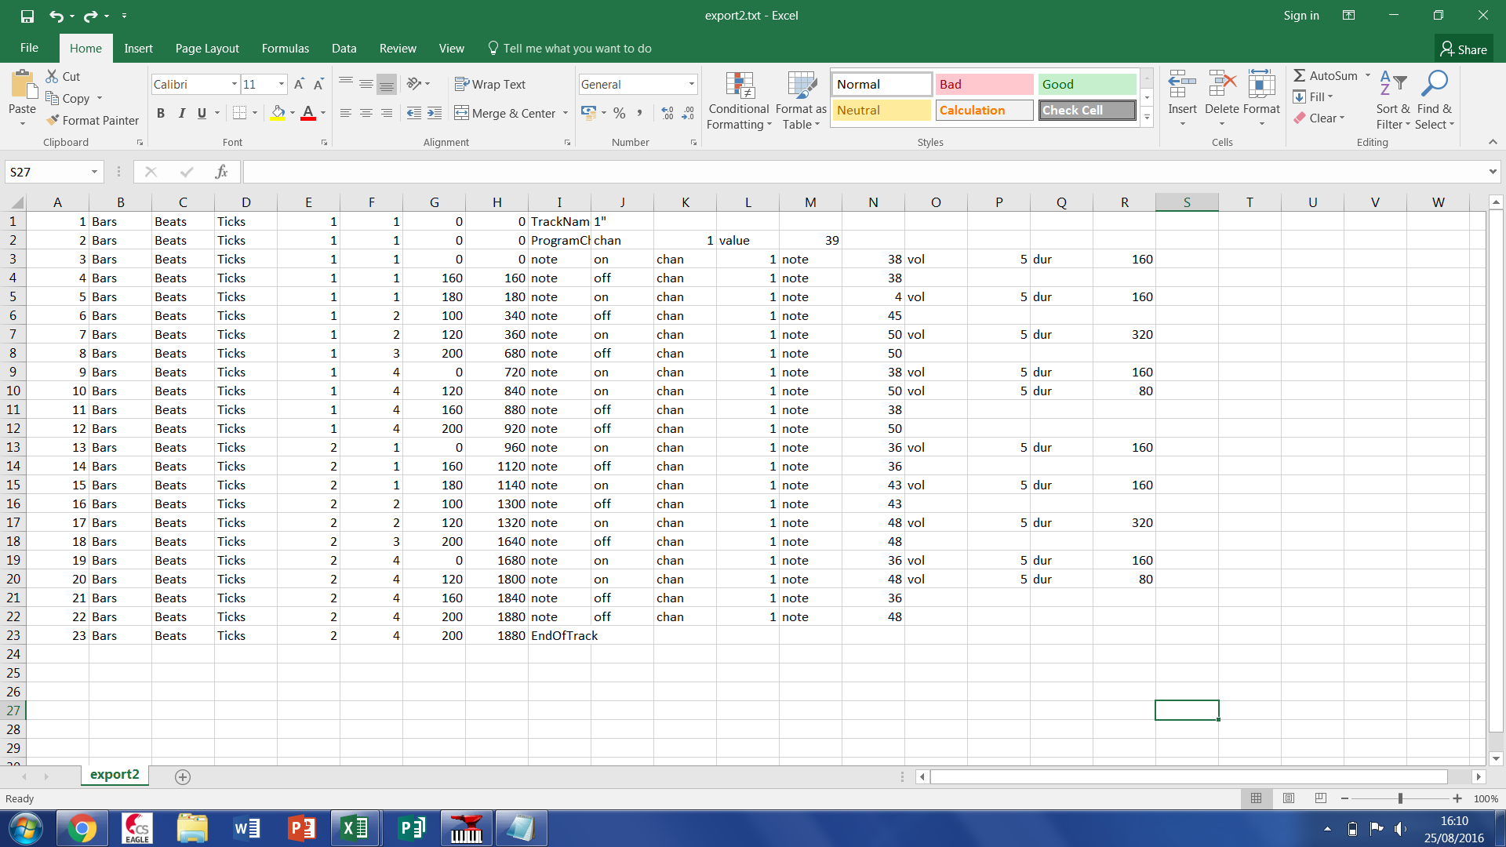

Delete the first two and last row

Then select the whole spreadsheet and click custom sort:

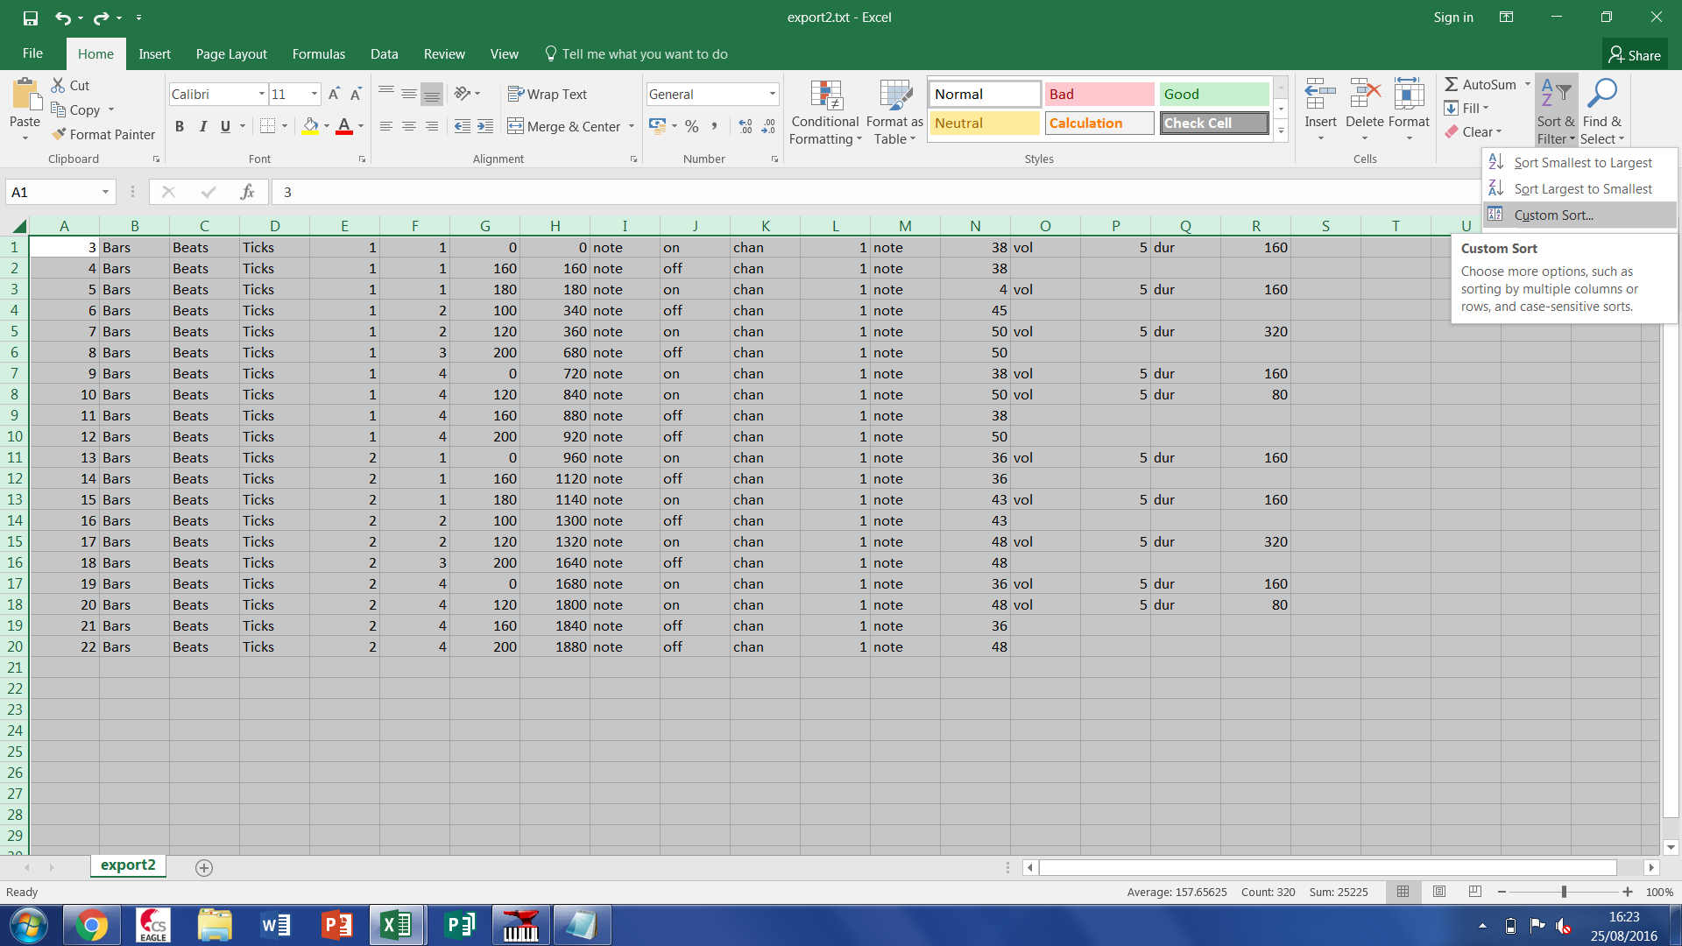

Sort alphabetically by column J:

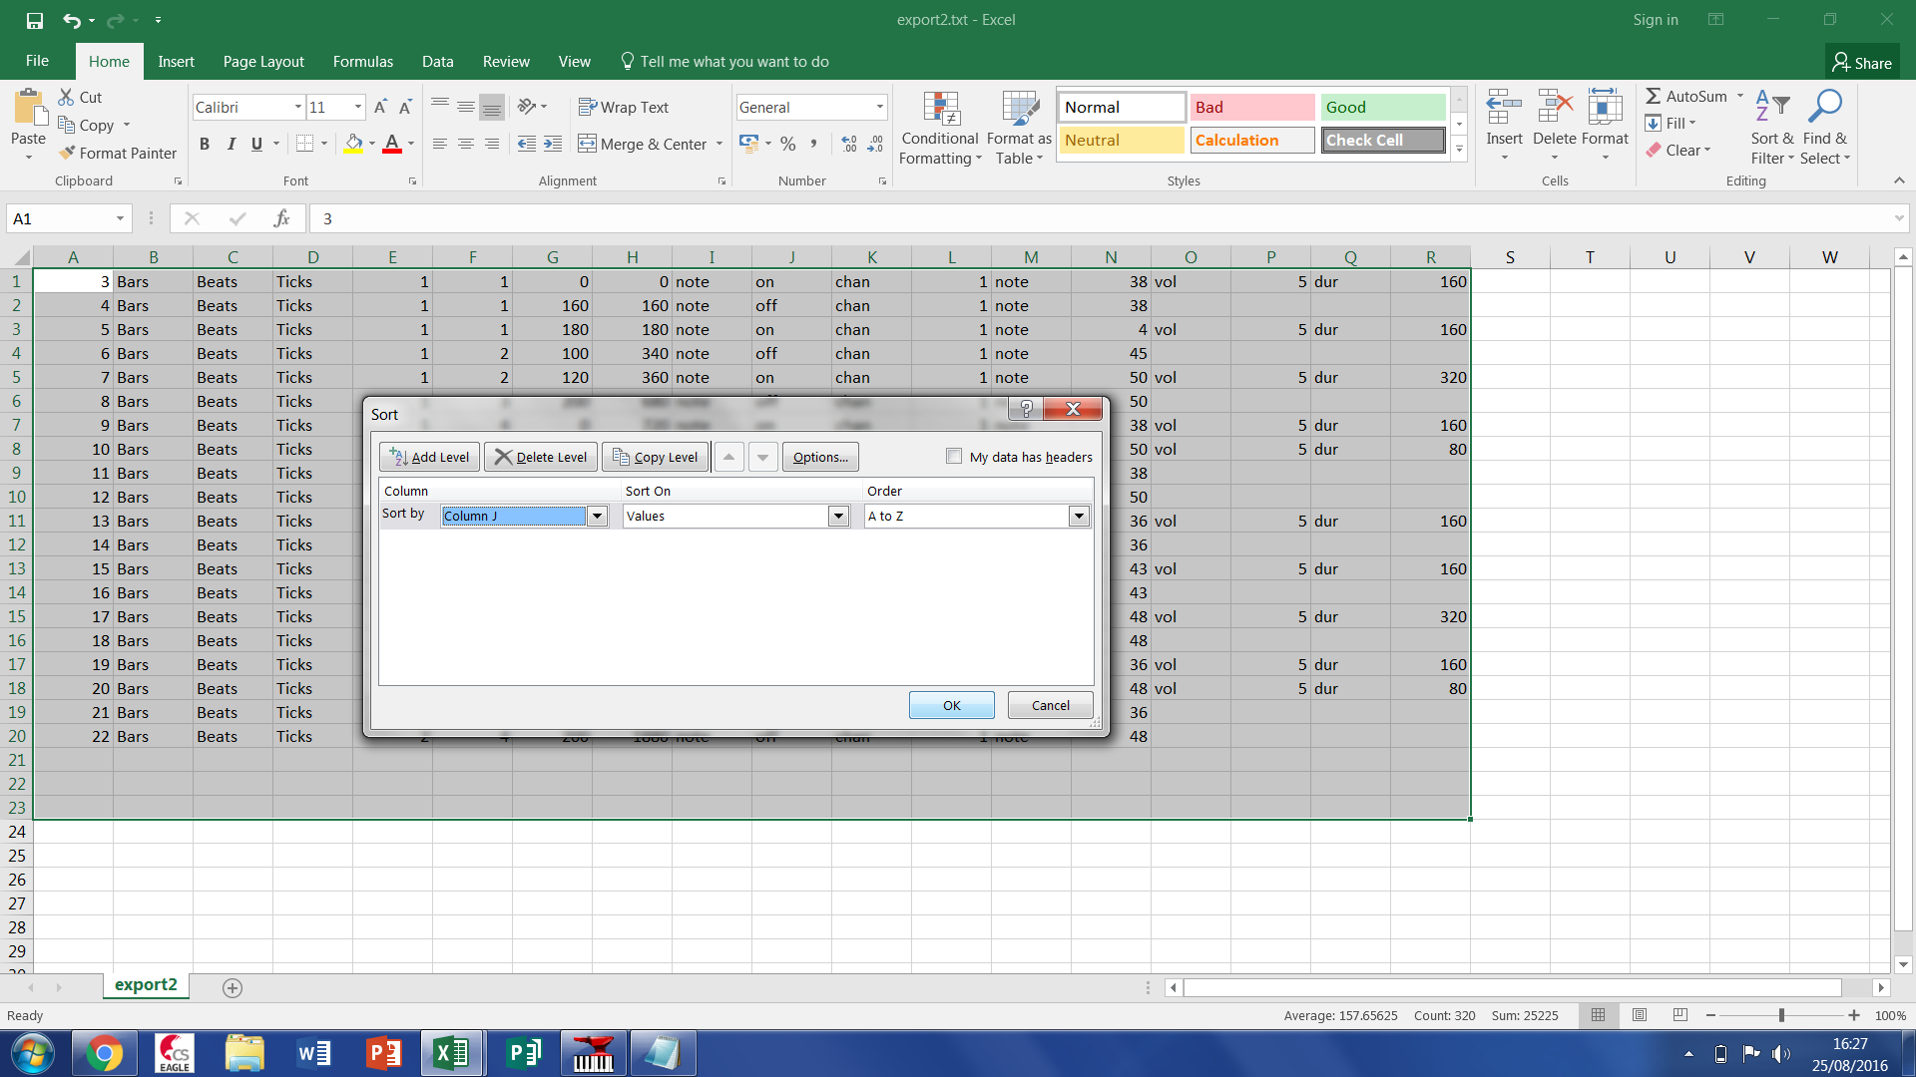

Then delete all the rows that say note off because we only want to know when the note starts:

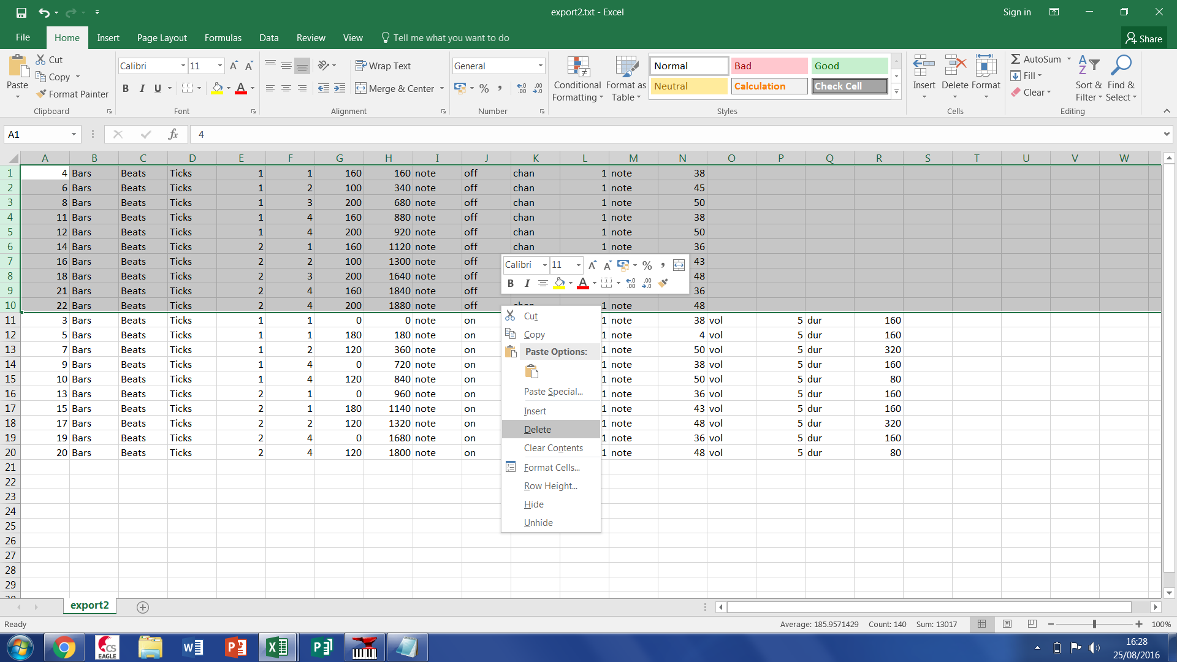

Then add two new tabs at the base naming one “Align” and the other “CSV”:

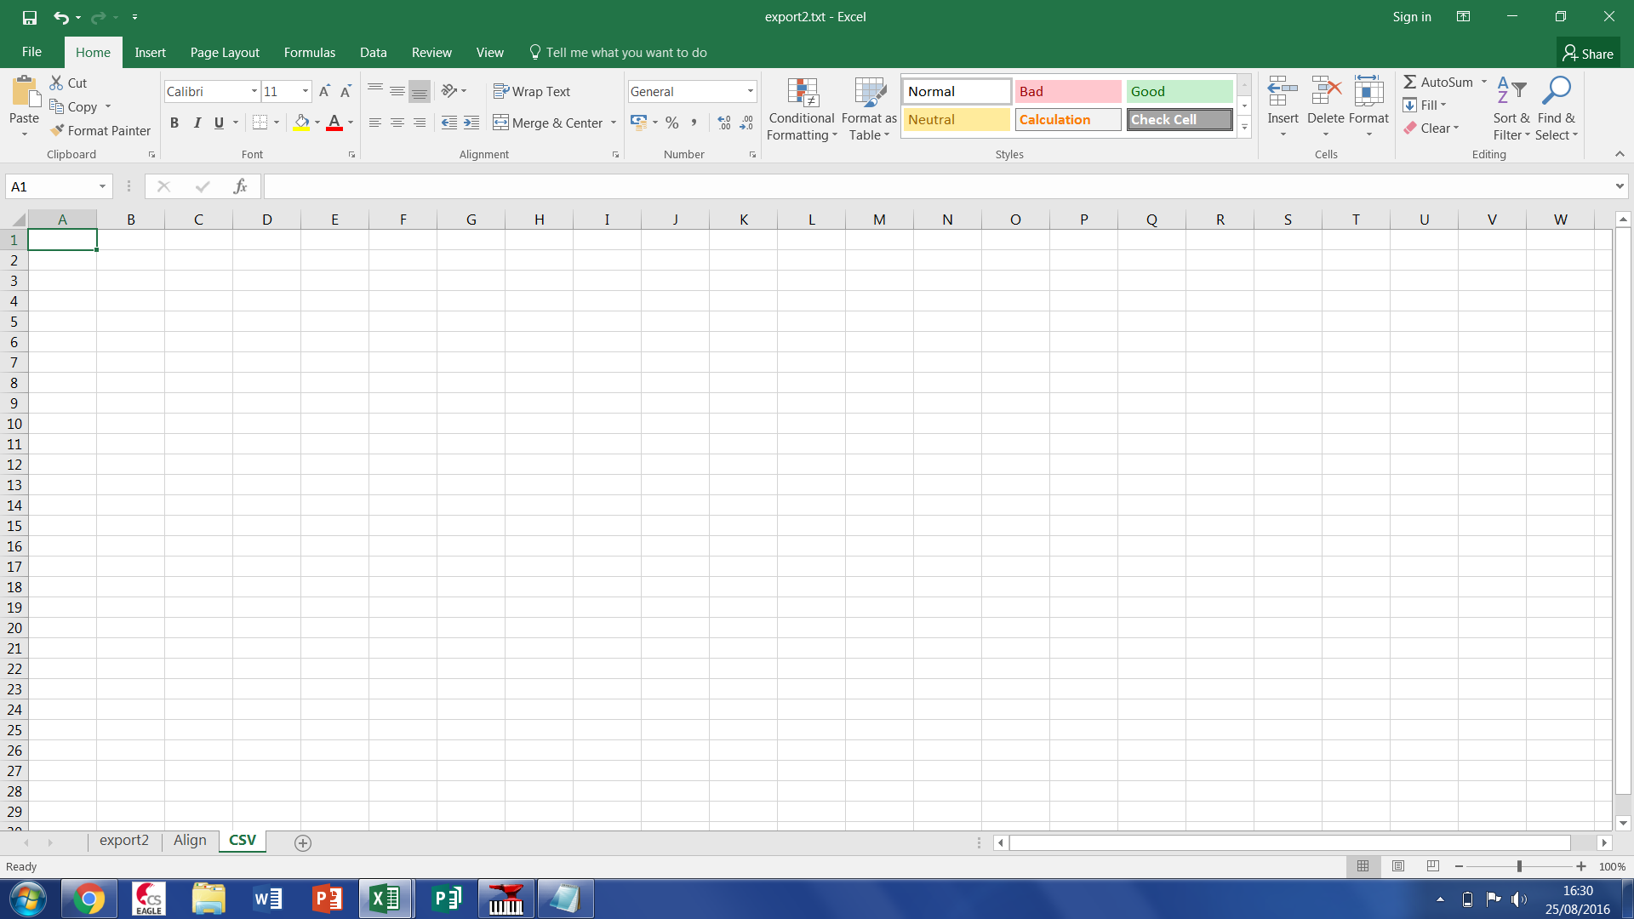

!i!i Keep in mind you will have to do this for all tracks in your piece !i!i

Make an extra column after the total number of ticks

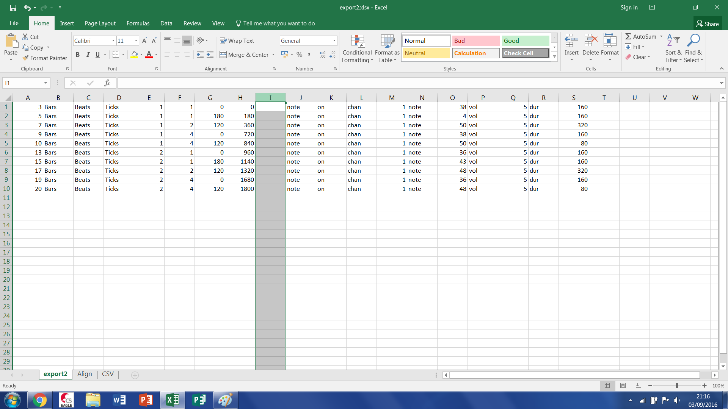

In which put the equation H1 / (240/the level of quantizeation you did) eg. 120 for 8th, 60 for 16th and 30 for 32th in my case the quantizeation was to a 16th so i’ll do H1/60 in the function box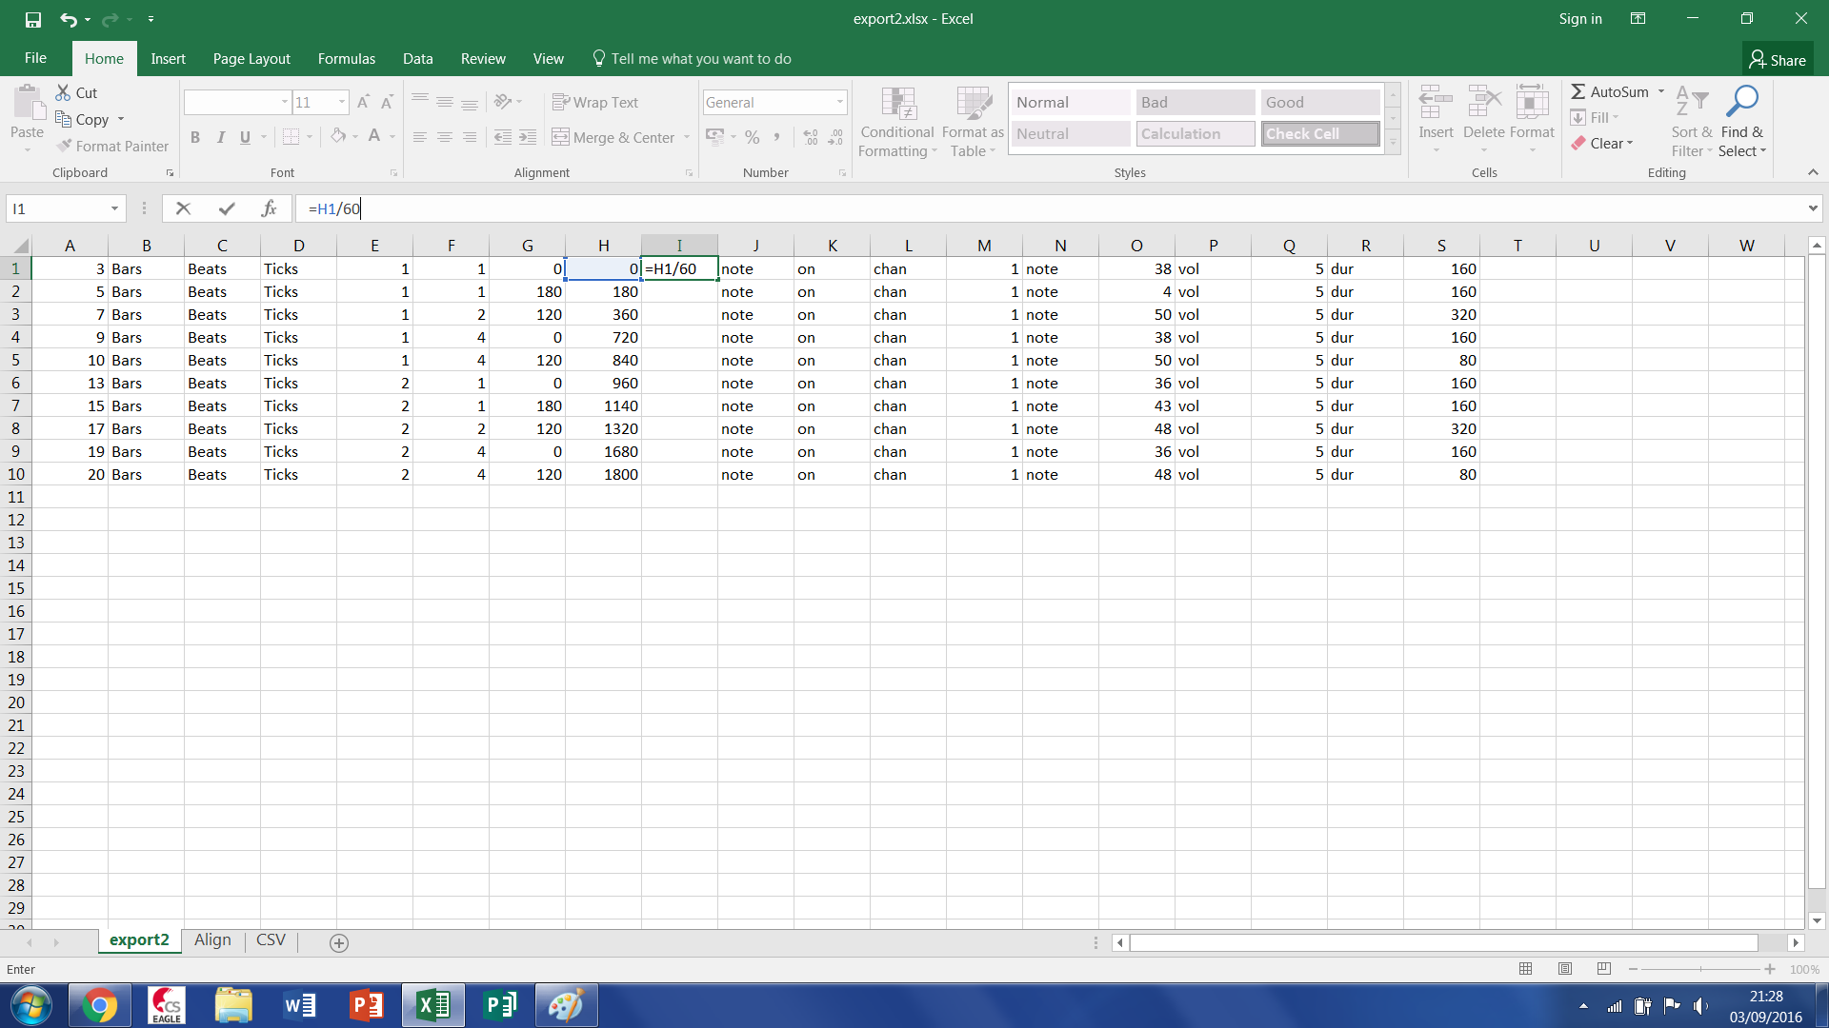

Find the length of the piece using the column you just made taking the smallest first number from the biggest last that includes all other tracks

Open the align tab and add in all the number from 1 to your piece length in ticks (you can do this by typing in the number 1 into the first cell and dragging it down a few places and selecting the option fill series and dragging it down to the number of ticks in your piece.)

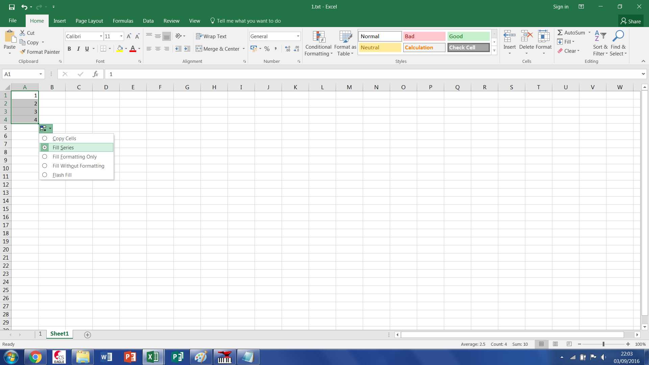

Then go to column D and copy and paste **values** the column with your quantised total ticks an take note of its length in terms of the row in which the final value is

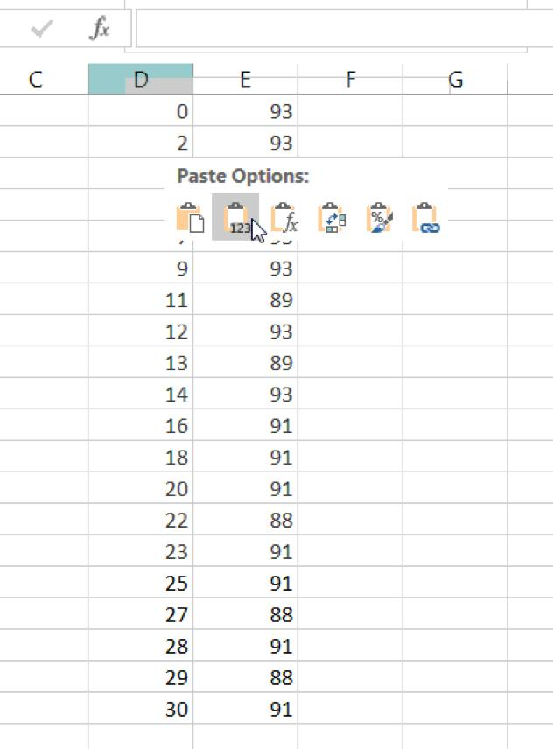

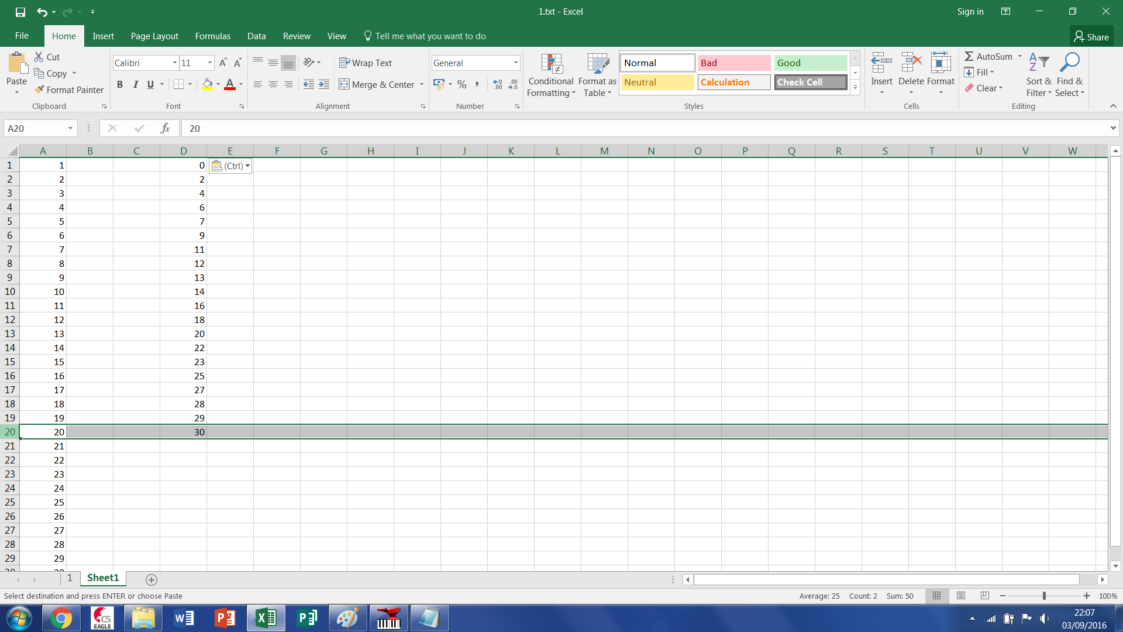

In column E paste the notes

Then copy and paste the formula: =IFERROR(VLOOKUP(A3235,$D$1:$E$???,2,FALSE),0) into the first cell of column B

Then set the three question marks to the number you noted down a second ago and check the coloured box covers all the data

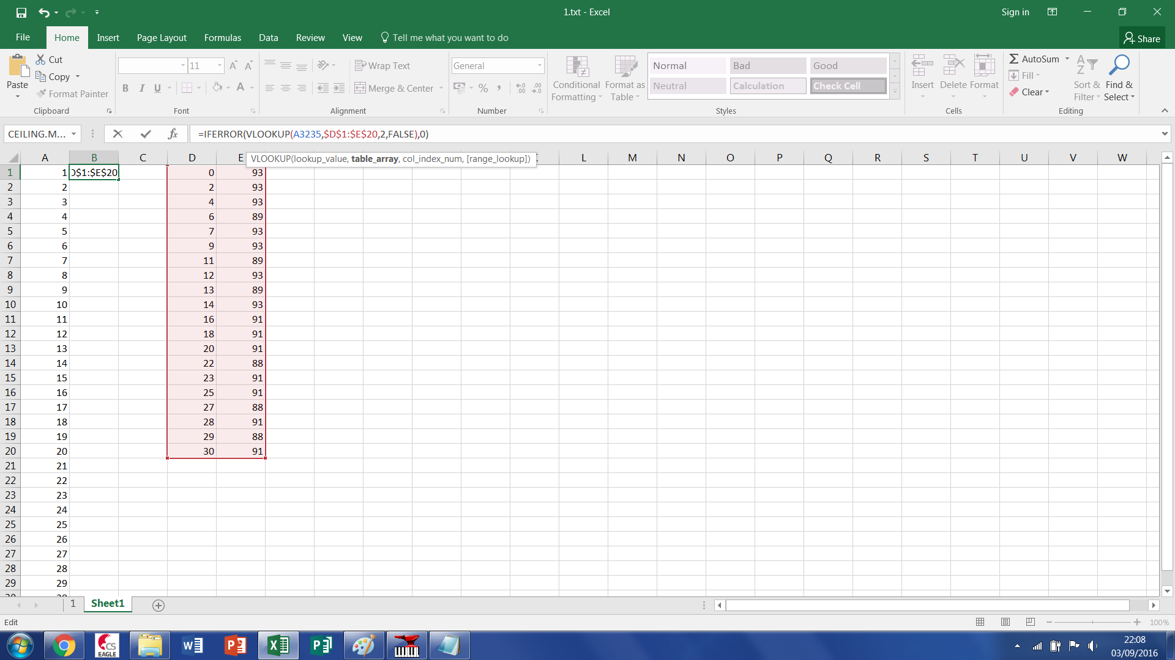

and then drag it down to the end of the time base

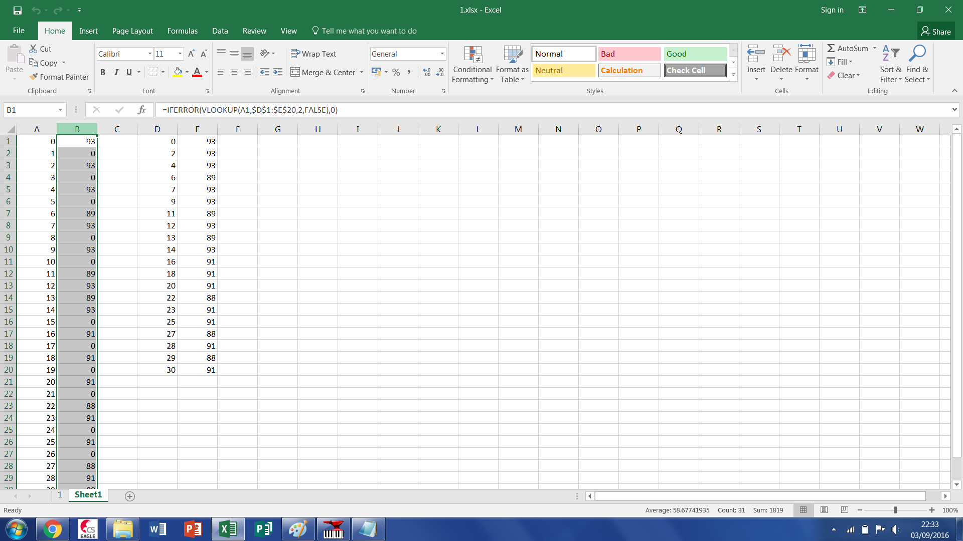

this is your csv file but it is in the wrong orientation so go into your CSV tab and paste **values** thecsv and insert two rows above it,

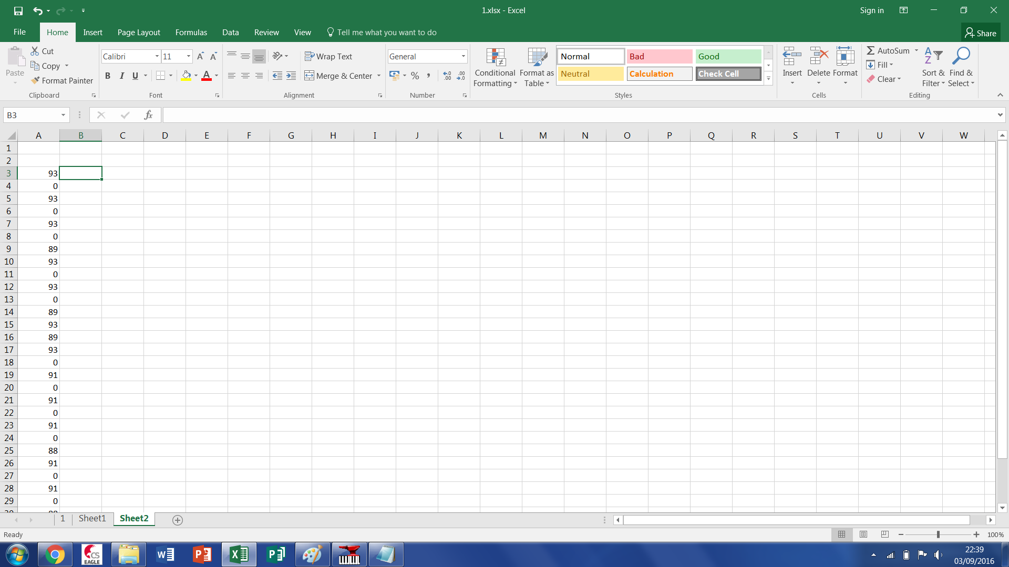

Then paste **tranpose** the vertical csv and it should paste in horizontally

Save the document as an excel document then as a .csv and open the file manager

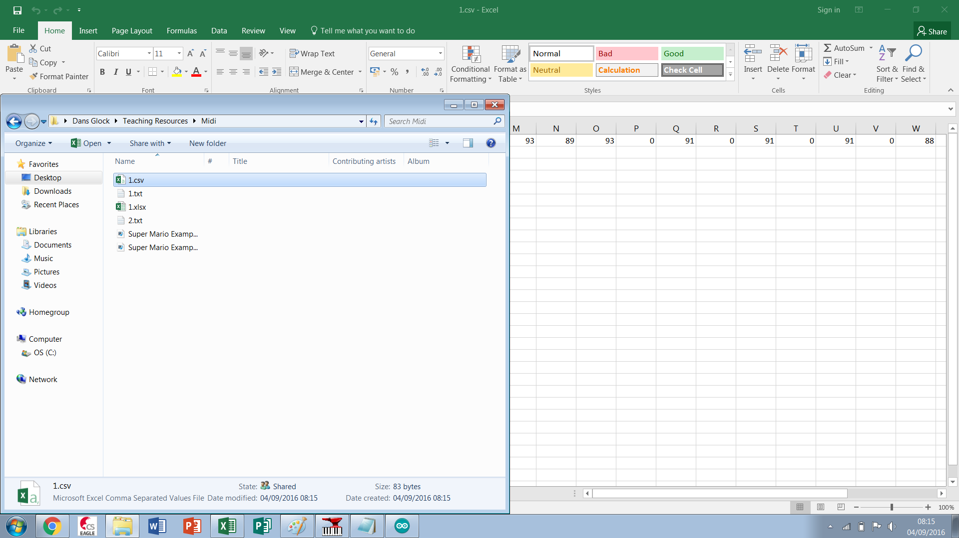

Rename the csv to (document name).txt and copy and paste it between the curly brackets in the glock-o-bots code

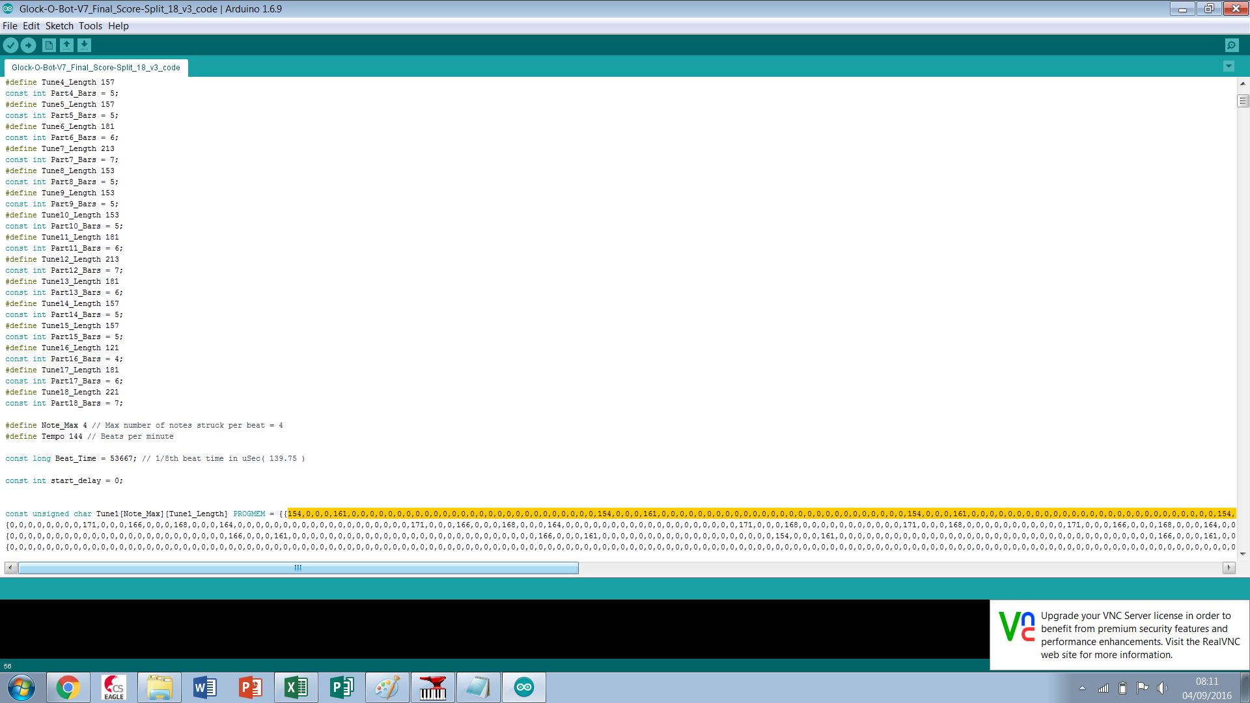

Fin